PRODUCTS WEBSITE

Login Page

Logic: Used jawa script
<script>
const form = document.getElementById("loginForm");
const username = document.getElementById("email");
const password = document.getElementById("password");
const message = document.getElementById("message");

form.addEventListener("submit", function (e) {
e.preventDefault();
message.textContent = "";
message.style.color = "red";

const emailValue = username.value.trim();
const passwordValue = password.value.trim();
const specialCharPattern = /[!@#$%^&*(),.?":{}|<>]/;

if (emailValue === "" && passwordValue === "") {
message.textContent = "Enter email and password";
} else if (emailValue === "") {
message.textContent = "Enter email";
} else if (!emailValue.includes("@gmail.com")) {
message.textContent = "Email must contain '@gmail.com'";
} else if (passwordValue === "") {
message.textContent = "Enter password";
} else if (passwordValue.length < 8) {
message.textContent = "Password must be at least 8 characters long";
} else if (!specialCharPattern.test(passwordValue)) {
message.textContent = "Password must include at least one special character";
} else {
message.style.color = "green";
message.textContent = "Login successful! Redirecting...";

setTimeout(() => {
window.location.href = "home.html";
}, 1000);
}
});
</script>

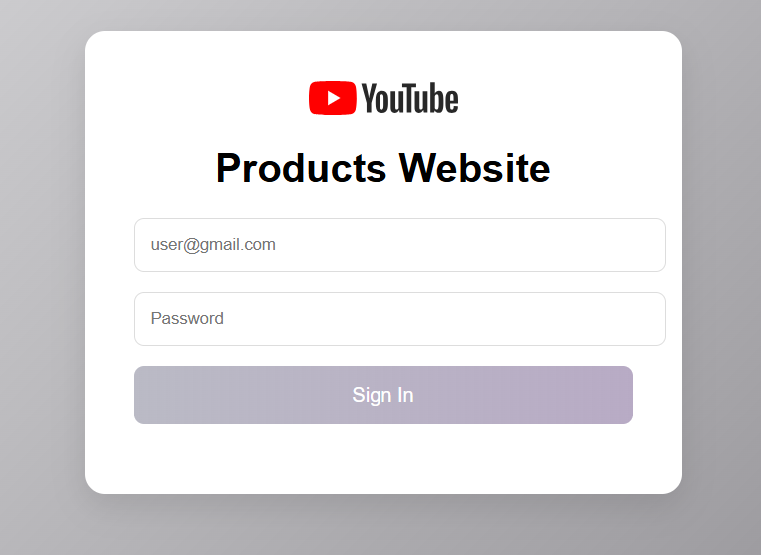

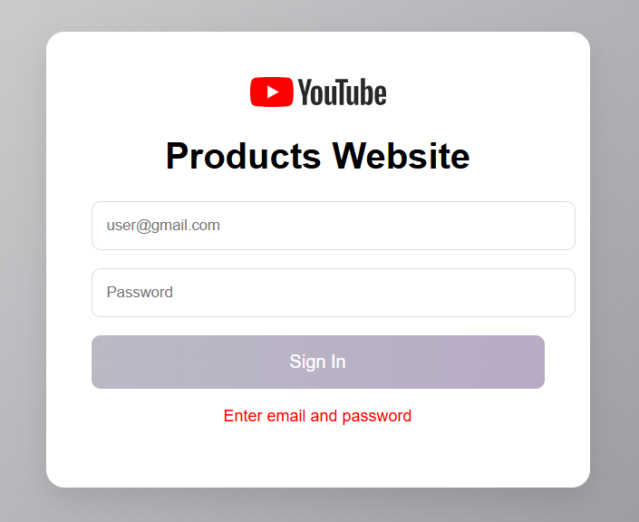

Home page:

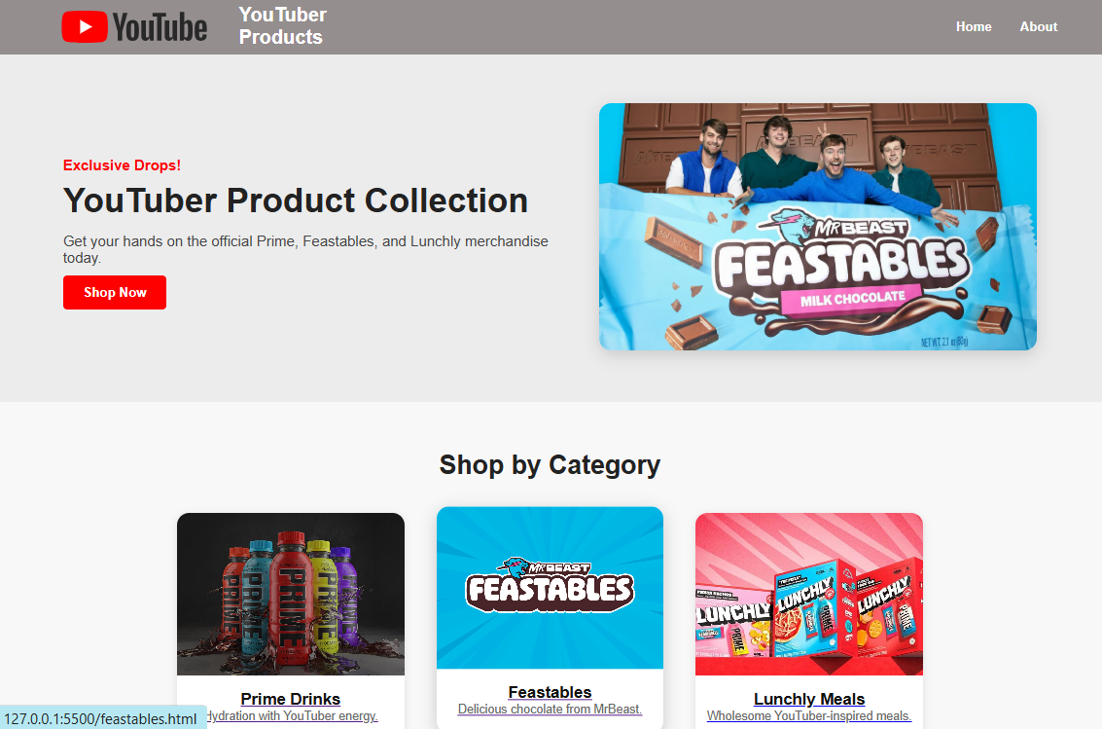

Scrolling pic code:
<div class="slide fade">
<img src="homeimg/pop.jpg" alt="Feastables 3">
</div>

Prime HTML:

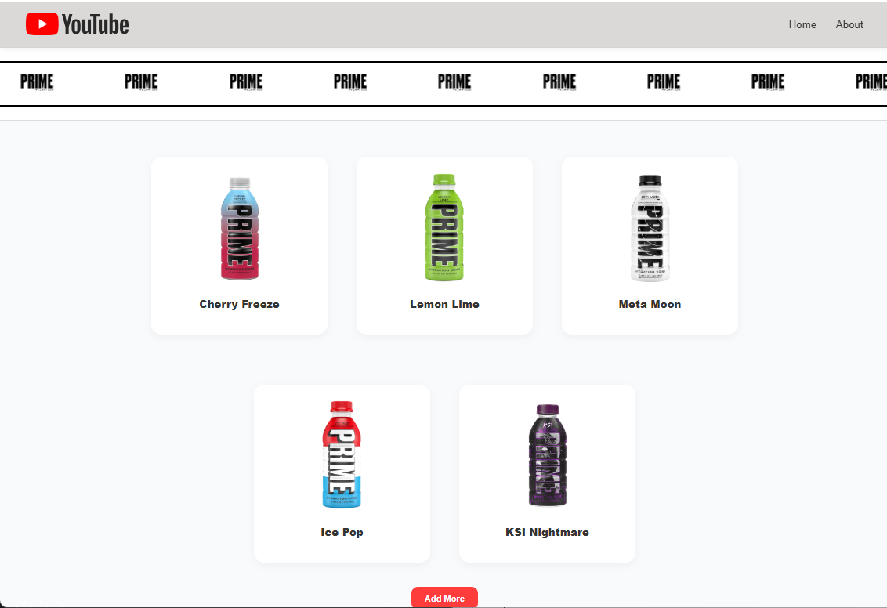

After clicking add more:
function addMore() {
const newProduct = {
name: "Orange Kream",
img: "images/OrangeKream.jpeg.webp"
};

const container = document.getElementById("row2");
const proDiv = document.createElement("div");
proDiv.className = "pro";
proDiv.innerHTML = `
<div class="product">
<div class="img"><img src="${newProduct.img}" height="180px"></div>
<div class="text"><p><b>${newProduct.name}</b></p></div>
</div>`;
container.appendChild(proDiv);

// Hide button
document.getElementById("addMoreBtn").style.display = "none";
}

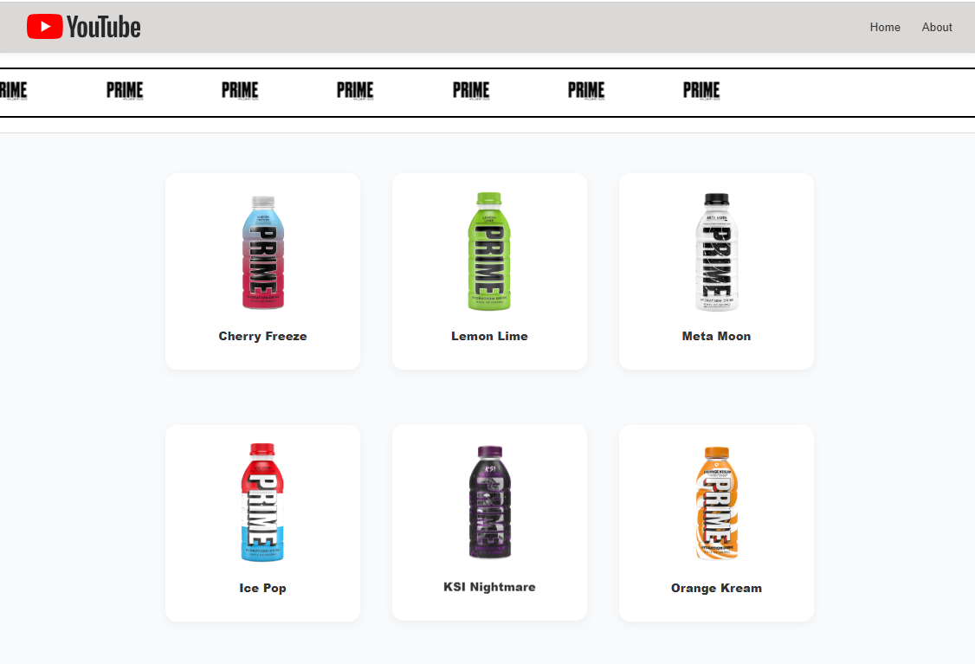

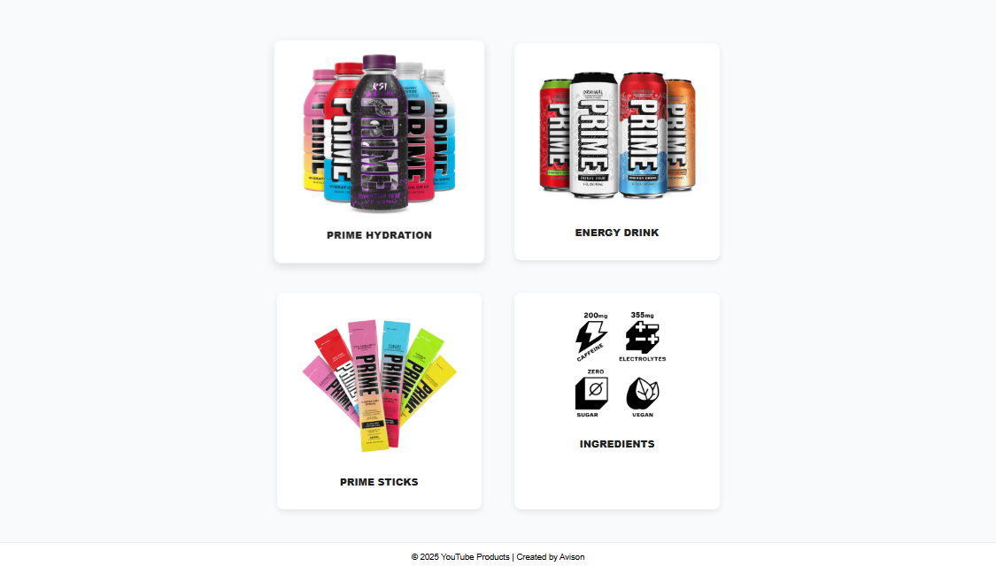

On clicking lemon lime: Jawa script

function openLemonLime() {
alert("Lemon Lime selected!");
window.location.href = "primelemon.html";
}

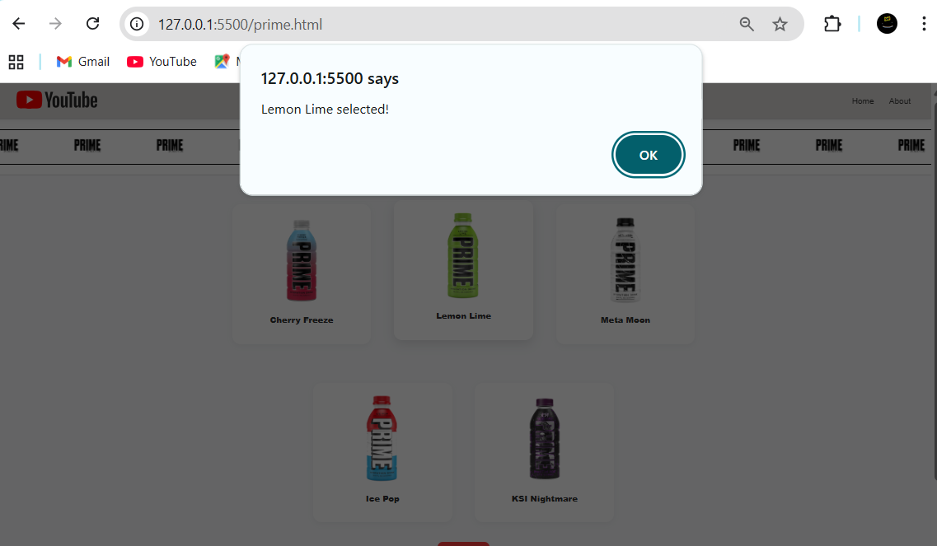

Main Page regarding info:

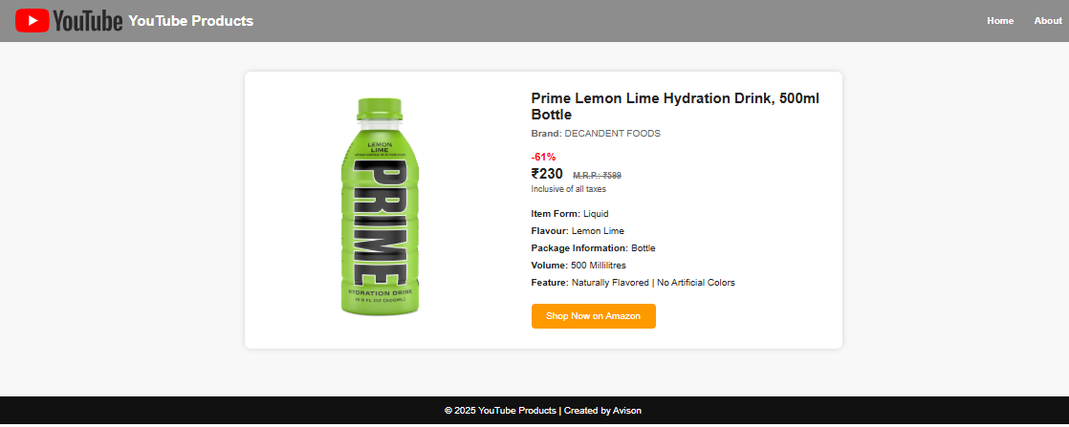

Redirects to Amazon:
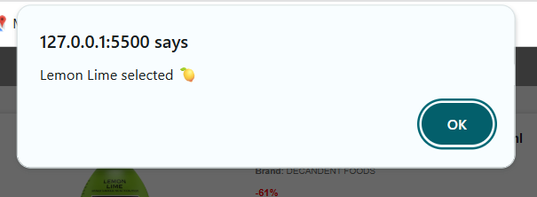

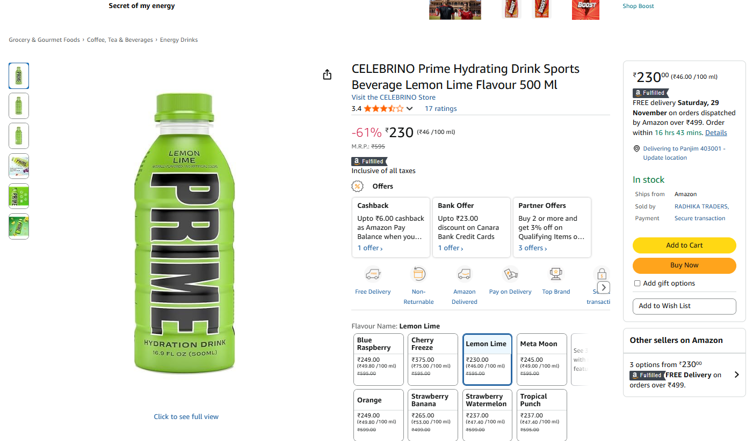

Feastables HTML: Same has been used here except for video tag

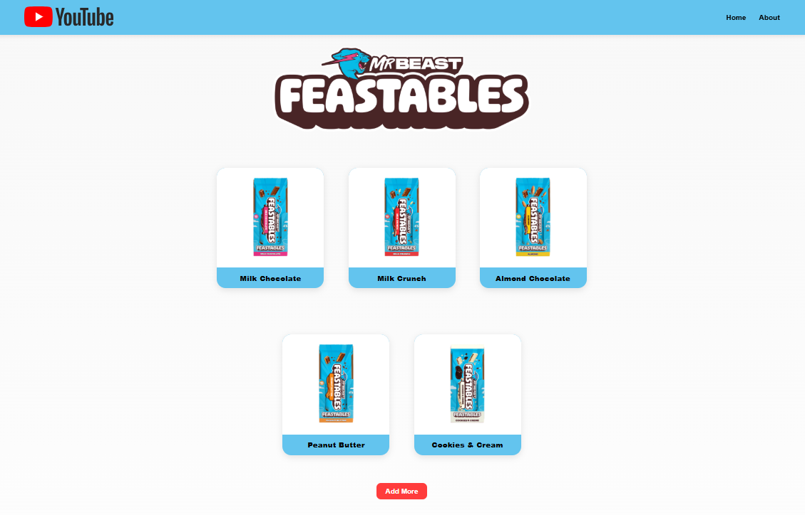
Add more:

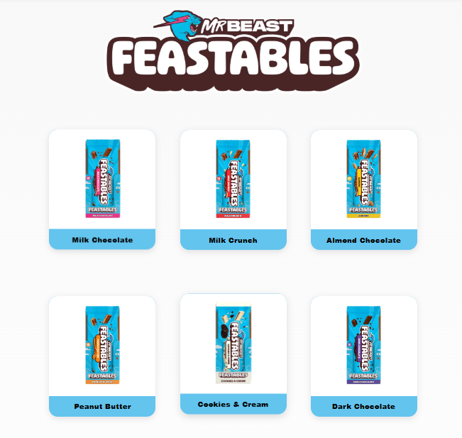

Video Tag:
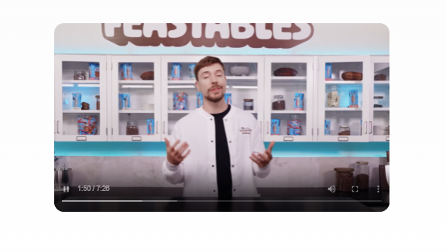

<center>
<video controls loop height="390px" class="video" autoplay>
<source src="homeimg/IMG_8844.MOV" type="video/mp4">
<source src="homeimg/IMG_8844.MOV" type="video/ogg">
</video>
</center>

Clicking Milk Crunch:

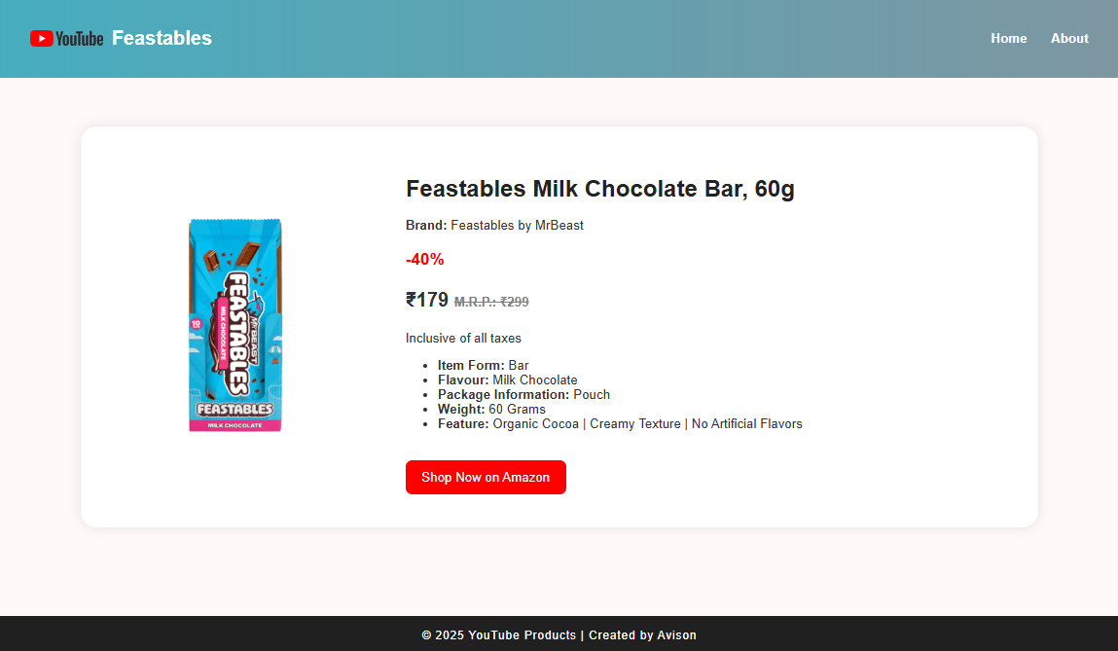

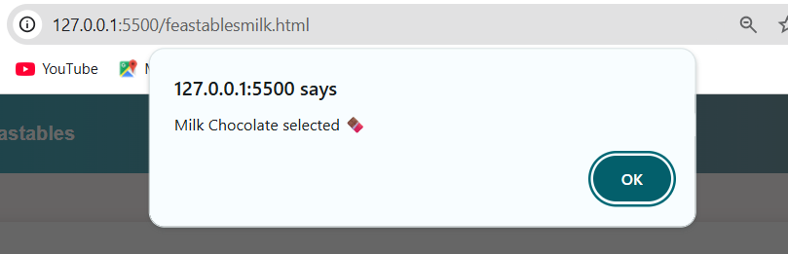

Redirecting to Amazon:

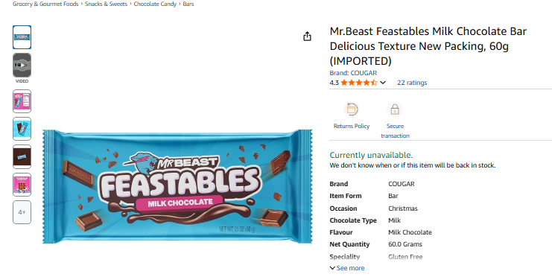

About Page:

